Name: ALVEENA NAZ
REG NO. FA25-BSE-010
SUBJECT: OOP (LAB 1 & LAB 2)
11- Feb-2026

Lab task 1:
// main class
package main;
public class Main {
public static void main(String[] args) {
// first object
Student s1 = new Student ("alveena","OOP",81);
s1.display();
// second object
Student s2 = new Student ("lavizah","OOP",86);
s2.display();
}

}// class

package main;
// Student class
public class Student {
String name;
Int roll;
int marks;
// default constructor
Student()
{
name = " none";
roll = 0;
marks = 0;
}
// parametrized constructor
Student(String name,int roll,int marks)
{
this.name = name;
this.roll = roll;
this.marks=marks;
}
// display attributes
public void display()
{
System.out.println("name: " + this.name);
System.out.println(“Roll no: " + this.roll);
System.out.println("Marks: " + this.marks);
}

}

OUTPUT:
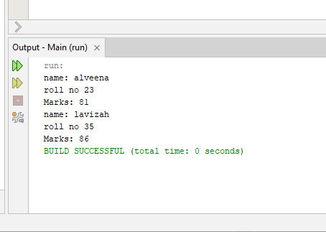

Lab task 2:
package javaapplication8;
public class JavaApplication8 {
public static void main(String[] args) {
Car c1 = new Car("Toyota","Qwe1",500000);
c1.display();
}

}
// class

package javaapplication8;
public class Car {
String brand;
String model;
int speed;
Car(String b,String m,int s){
this.brand = b;
this.model = m;
this.speed=s;
}
public void display(){
System.out.println("Brand:" + brand);
System.out.println("Model: " + model);
System.out.println("Speed " + speed);
}

}
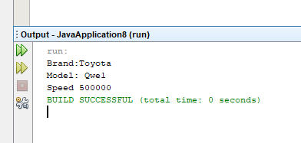

Lab 3:
package javaapplication8;
public class JavaApplication8 {
public static void main(String[] args) {
Rectangle rect = new Rectangle(2,2);
rect.area();
}

}
// class

package javaapplication8;
public class Rectangle {
int length;
int width;
Rectangle(int l,int w){
length=l;
width =w;
}
public void area(){
System.out.println("area " + length*width);
}
}
OUTPUT:
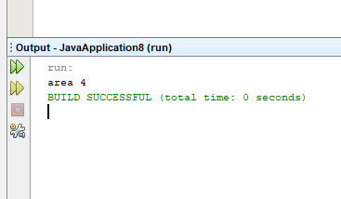

Lab 4:
//main class
public class JavaApplication5 {
public static void main(String[] args) {
Time t1 = new Time(3,12,24);
t1.display();
Time t2 = new Time(2,1,7);
t2.display();
}

}
// Time class
public class Time {
int hr;
int min;
int sec;
// empty constructor
Time()
{

}
//parametrized constructor
Time(int hr,int min,int sec)
{
this.hr=hr;
this.min=min;
this.sec=sec;

}
// display method
public void display()
{
System.out.println("Hour: " + hr + " Minute: " +min + " Seconds: " + sec);

}

}
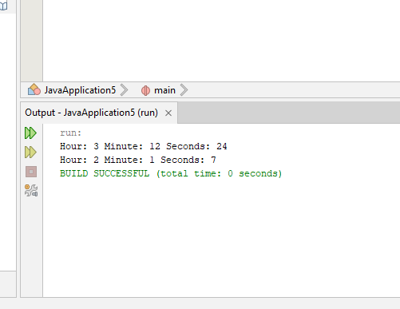

LAB 2
Task 1:
// main class
public class JavaApplication1 {
public static void main(String[] args) {
Circle c1 = new Circle(4);
c1.circumference();
}

}
// Circle class
public class Circle {
int radius;
//empty constructor
Circle()
{

}
//parametrized constructor
Circle(int r){
this.radius = r;
}
public void circumference(){
System.out.println("Circumference of acircle is " + (Math.round(Math.PI * radius * radius)));
}
}
OUTPUT:

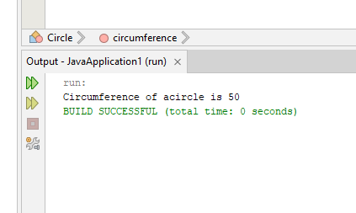

Task 2:
// main class
import java.util.Scanner;
public class JavaApplication2 {
public static void main(String[] args) {
Scanner input = new Scanner(System.in);
Account acc1 = new Account(5000);
System.out.println("1.Deposit money\n 2.withdraw money");
System.out.println("enter your choice");
int choice = input.nextInt();
if(choice==1)
{
System.out.println("Enter amount to deposit");
int money = input.nextInt();
acc1.deposit(money);
}
else if(choice==2)
{
System.out.println("Enter amount to withdraw");
int money = input.nextInt();
acc1.withdraw(money);
}
}

}
// account class
public class Account {
int balance;
// default constructor
Account(){

}
// parametrized constructor
Account(int b){
this.balance = b;
}
public void deposit(int money){
balance+=money;
System.out.println("Your new balance is " + balance);
}
public void withdraw(int money){
balance-=money;
System.out.println("withdraw money is " + money);
}
}
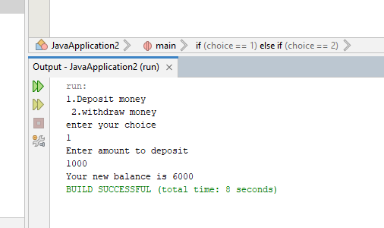
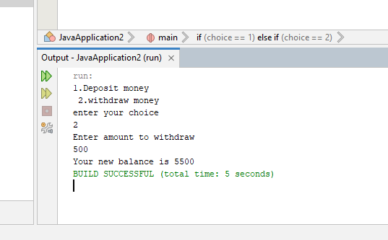

Task 3:
// main class
public class JavaApplication3 {
public static void main(String[] args) {
Distance d = new Distance(4,5);
d.display();
}

}
// Distance class
public class Distance {
int feet;
int inches;
Distance()
{

}
Distance(int feet,int inches)
{
this.feet = feet;
this.inches = inches;
}
public void display()
{
System.out.println(" Feet " + feet + " Inches " + inches);
}
}

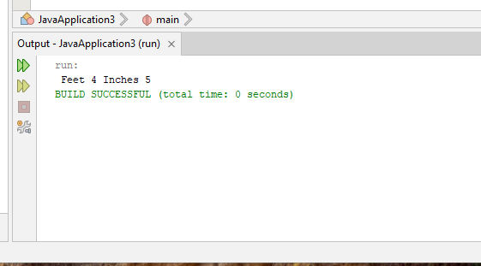

Task 4:
//main class

public class JavaApplication4 {
public static void main(String[] args) {
Marks m = new Marks(23,44,55);
System.out.println(" Sum of marks is " + m.sum());

}

}
// marks class
public class Marks {
int marks1;
int marks2;
int marks3;
Marks()
{

}
Marks(int m1,int m2,int m3)
{
this.marks1=m1;
this.marks2 = m2;
this.marks3 = m3;
}
public int sum()
{
int sum;
sum = marks1 + marks2 + marks3;
return sum;
}
}
OUTPUT:

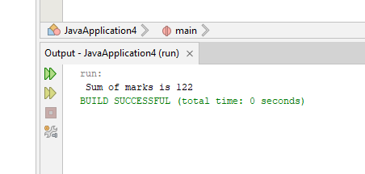

Task 5:
// main class
public class JavaApplication5 {
public static void main(String[] args) {
Time t1 = new Time(3,12,24);
t1.display();
Time t2 = new Time(2,1,7);
t2.display();
}

}
//Time class
public class Time {
int hr;
int min;
int sec;
// empty constructor
Time()
{

}
//parametrized constructor
Time(int hr,int min,int sec)
{
if(hr>=0&&hr<=24)
{
this.hr = hr;
}
if(min>=0&&min<=60){
this.min = min;
}
if(sec>=0 && sec<=60){
this.sec = sec;
}

}
// display method
public void display()
{
System.out.println("Hour: " + hr + " Minute: " +min + " Seconds: " + sec);

}

}
OUTPUT:

